Compétence 2 : Concevoir une base de données
DATA_WIND

1. DICTIONNAIRE DE DONNÉES

2. MCD

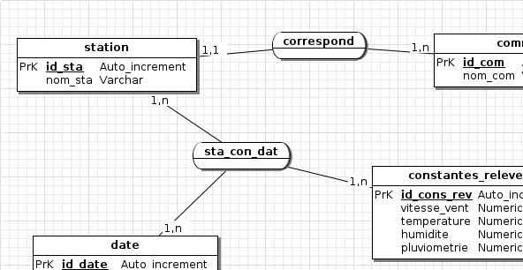

3. MLD

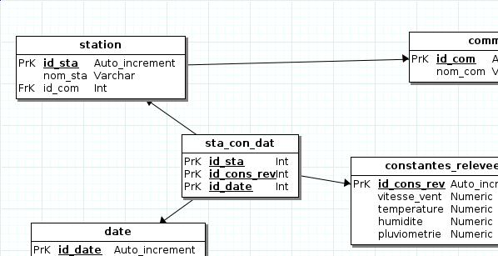

4. SGBD CHOISI



5. MPD

#------------------------------------------------------------
# Script MySQL.
#------------------------------------------------------------

#------------------------------------------------------------
# Table: station
#------------------------------------------------------------

CREATE TABLE station(
id_sta int (11) Auto_increment NOT NULL ,
nom_sta Varchar (200) NOT NULL ,
id_com Int ,
PRIMARY KEY (id_sta )
)ENGINE=InnoDB;

#------------------------------------------------------------
# Table: constantes_relevees
#------------------------------------------------------------

CREATE TABLE constantes_relevees(
id_cons_rev int (11) Auto_increment NOT NULL ,
vitesse_vent Numeric NOT NULL ,
temperature Numeric NOT NULL ,
humidite Numeric NOT NULL ,
pluviometrie Numeric NOT NULL ,
PRIMARY KEY (id_cons_rev )
)ENGINE=InnoDB;

#------------------------------------------------------------
# Table: date
#------------------------------------------------------------

CREATE TABLE date(
id_date int (11) Auto_increment NOT NULL ,
date_jour Date NOT NULL ,
heure Datetime NOT NULL ,
PRIMARY KEY (id_date )
)ENGINE=InnoDB;

#------------------------------------------------------------
# Table: commune
#------------------------------------------------------------

CREATE TABLE commune(
id_com int (11) Auto_increment NOT NULL ,
nom_com Varchar (200) NOT NULL ,
PRIMARY KEY (id_com )
)ENGINE=InnoDB;

#------------------------------------------------------------
# Table: sta_con_dat
#------------------------------------------------------------

CREATE TABLE sta_con_dat(
id_sta Int NOT NULL ,
id_cons_rev Int NOT NULL ,
id_date Int NOT NULL ,
PRIMARY KEY (id_sta ,id_cons_rev ,id_date )
)ENGINE=InnoDB;

ALTER TABLE station ADD CONSTRAINT FK_station_id_com FOREIGN KEY (id_com) REFERENCES commune(id_com);
ALTER TABLE sta_con_dat ADD CONSTRAINT FK_sta_con_dat_id_sta FOREIGN KEY (id_sta) REFERENCES station(id_sta);
ALTER TABLE sta_con_dat ADD CONSTRAINT FK_sta_con_dat_id_cons_rev FOREIGN KEY (id_cons_rev) REFERENCES constantes_relevees(id_cons_rev);
ALTER TABLE sta_con_dat ADD CONSTRAINT FK_sta_con_dat_id_date FOREIGN KEY (id_date) REFERENCES date(id_date);

